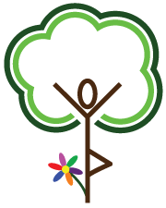**Learning Tree Yoga**

*A yoga studio just for kids!*

*Girl Scout Planning Form*

Troop Location/#

Contact Person

Contact Info. (p) (email)

Date/Time of Lesson

Location of Meeting

*Please note there is an $90 minimum if distance is 20+ miles from LTY.

Age/Grade of Students

Please Circle Troop Theme:

**DAISY**

**Purple Petal "Respect Myself and Others"**

We will discuss what respect means and how it affects ourselves and others. We will have fun doing yoga poses and finish with a guided visualization.

**Red Petal "Courageous and Strong"**  
We will discuss what courageous means, and what it means to be strong in our mind and body. We will do yoga poses that help us to be peaceful warriors.



**BROWNIE**

**My Best Self**  
It is so much fun to get to know your body and play in a healthy way through yoga poses. We will keep our bodies moving, and end with a guided visualization to calm our bodies down.

**A close up of a logo

Description generated with high confidence**

**JUNIOR**

**Staying Fit Badge.**  
We will learn sun salutations, yoga flows, and poses to enhance fitness along with breathing techniques and a guided visualizations to handle stress.

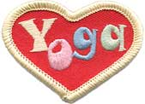

*Yoga Fun Patch available!*

*Additional $1.00*

**Pricing Options:**

*$60 minimum fee.

Cost (WITHOUT Yoga Fun Patch):

Number of girls ______ x $9 = ________

Cost (WITH Yoga Fun Patch):

Number of girls ______ x $10 = ________

*\*Please note that official Girl Scout Badges are not included and need to be purchased separately. They are not available from Learning Tree Yoga.*

Please mail form to: Learning Tree Yoga Studio *500 38th Avenue NE #200, Minneapolis, MN 55421*

Or, email to Jessie at [jlforston@learningtreeyoga.com](mailto:jlforston@learningtreeyoga.com)